ANUIP FOUNDATION



**A Project Report On:**

**Hospital Management System**

**Year:** 2024-25

Submitted to:

**Anudip**

Submitted By:

Mr Aryan Meghraj Shivgunde

**(Web Programming in Python)**

# **Project Description**

* **Intro:**
* **T**he Hospital Management System is designed to streamline and automate the various functions and operations within a hospital. The primary aim is to enhance efficiency, improve guest experiences, and simplify the administrative tasks involved in managing a hospital.
* **Objectives**:
* To streamline hospital workflows and administrative processes.
* To digitize patient records for quick access and better management.
* To improve communication between doctors, nurses, and administrative staff.
* To enhance patient experience by reducing wait times and improving service delivery.
* To manage hospital inventory and ensure the availability of necessary medicines and equipment.
* **Features:**
* User-friendly Interface
* Online optiment for customer’s/management.
* Secure payment gateway integration.
* Automated notifications via email/SMS.
* Role-based access control for staff and administrators.
* Mobile-responsive design for accessibility.
* Patient Registration
* Electronic Health Records (EHR)
* Appointment Management
* Billing Module
* Inventory Control
* Reporting Tools
* User Authentication
* **Solution:**

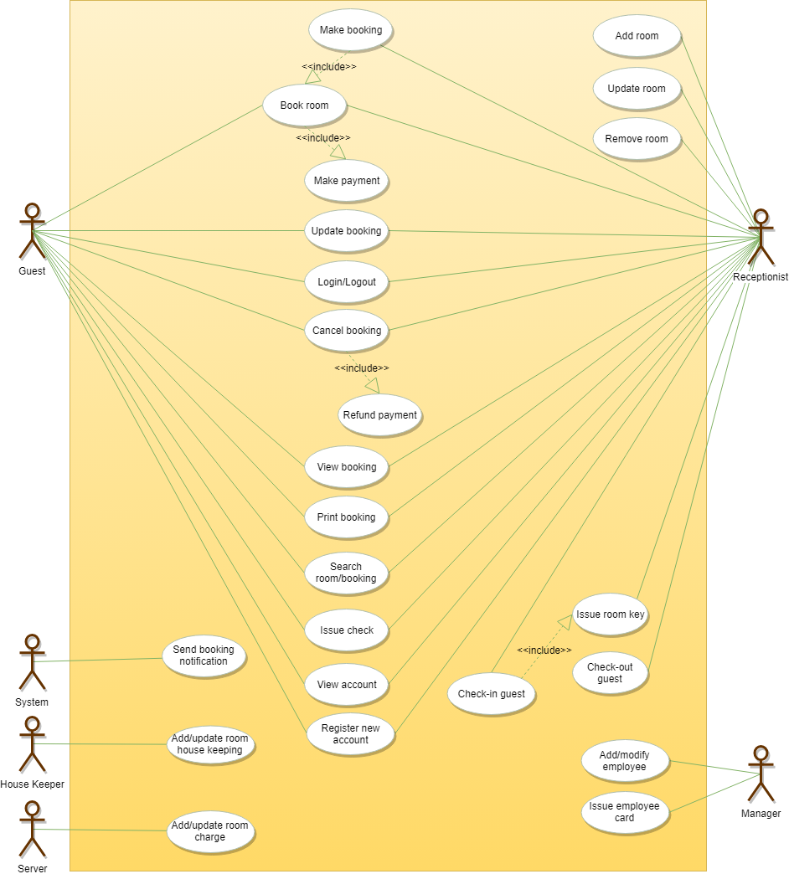

**Project Requirement’s:**

* **Software Requirement:**

|  |  |
| --- | --- |
| **Component** | **Specification** |
| 1.OS | Windows 10, Windows 8, Android, MacOS, or any operating system compatible with modern web browsers |
| 2.Browser | Brave, Chrome, Edge, Firefox, Safari, or any modern browser |
| 3. Fronennd Framework | HTML, CSS, JS, Django |
| 4. Programming Language: | Python |
| 5. Database: | Sqlite |
| 6. App Hosting: | loaclhost |

* **Hardware Requirements:**

|  |  |
| --- | --- |
| **Component** | **Specification** |
| 1. Processor: | AMD Ryzen or higher |
| 2.RAM: | 512MB or more |
| 3.Hard disk: | 10GB or more |
| 4.Devices: | Laptop, PC, Smartphones, Tablets,  or any device capable of running a web browser |
| 5.Keyboard: | Normal or Multimedia |
| 6.Mouse: | Compatible Mouse |

# **Conclusion:**

The Hospital Management System is a comprehensive and efficient solution that enhances operational efficiency and improves customer satisfaction. By integrating modern technologies, this system ensures seamless hospital management and a competitive edge in the hospitality industry

# **Reference:**

* https://chatgpt.com
* https://www.blackbox.ai/chat/PBuOPsa